Letter to the Editor

Iatrogenic Labral Puncture of the Hip Is Avoidable
- Benjamin G. Domb, M.D.,
- Itamar B. Botser, M.D.
- Westmont, Illinois
- http://dx.doi.org/10.1016/j.arthro.2011.12.002, How to Cite or Link Using DOI
- Permissions & Reprints
Refers to
- James Keene
- Author's Reply
- Arthroscopy: The Journal of Arthroscopic & Related Surgery, Volume 28, Issue 3, March 2012, Pages 307-308
- PDF (146 K)
To the Editor:
We read with great interest the recent article by Badylak and Keene¹ regarding iatrogenic labral puncture during hip arthroscopy. This study reported that the labrum was penetrated in 20% of cases and concluded that the iatrogenic labral injury did not affect the 1- and 2-year clinical results. We applaud the authors' candor in reporting this complication in a total of 50 patients and value the contribution of this article to the nascent body of literature on safe procedures in hip arthroscopy.
Indeed, labral injuries are reported as a complication of hip arthroscopy in the literature and may occasionally occur during hip arthroscopy despite the surgeon's best efforts to achieve safe access.^{2, 3 and 4} However, we fear that this article may unintentionally convey to the reader that a high rate of labral penetration is not a cause for concern. For this reason, we would like to emphasize to the readers that labral injury is not a normal part of hip arthroscopy and should be avoided when possible. According to our experience, it is possible to perform hip arthroscopy with a low incidence of labral penetration by following a simple safe technique for portal establishment during hip arthroscopy. Using this technique in a series of 300 consecutive cases, we have reported 2 labral penetrations (rate of labral injury, 0.67%).⁵ One injury occurred during revision arthroscopy, whereas the second involved a hyperplastic labrum in a dysplastic hip.
The safe technique that we use follows 2 basic principles to keep the labrum intact. The first is to vent the joint with the spinal needle and then to withdraw and re-enter the joint (Fig 1, Video 1, available at www.arthroscopyjournal.org). Venting the joint releases the negative intra-articular pressure, allowing greater distraction before entry with the cannula and arthroscope. The second principle is to consider the beveled side of the spinal needle as the “safe side”; tissues on the beveled side are retracted away and not penetrated (Fig 2). The safe side of the bevel may be used to pass first the labrum and then the femoral head during joint entry.
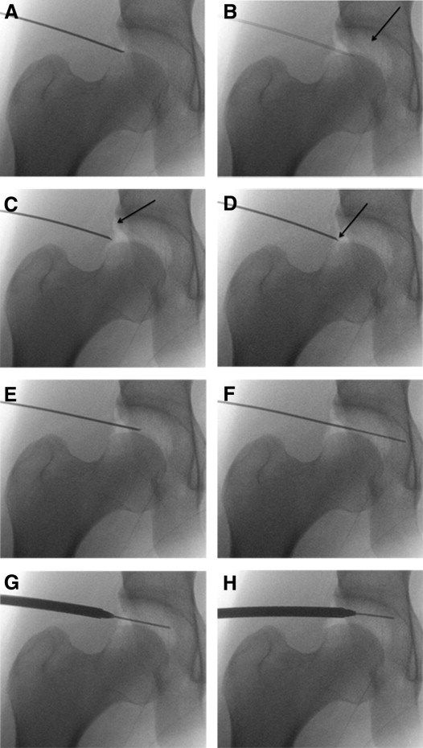
Figure 1. (A) A 14-gauge spinal needle is introduced at the anterior-lateral portal and advanced with the bevel, which is the “safe side,” facing toward the femoral head. (B) The stylet is removed to vent the joint, creating an air arthrogram (arrow) and increasing distraction. (C) The needle is withdrawn outside the capsule (arrow) and reinserted with the safe side facing the labrum to prevent labral penetration. (D) The needle is gently advanced until a “pop” is felt. The tip of the needle should be intracapsular (arrow). (E) The needle is rotated 180° and advanced into the joint with the safe side facing toward the femoral head to prevent scuffing. (F) A nitinol wire is passed through the needle until it makes contact with the acetabular wall; the needle is then withdrawn and the wire left in place. (G) A dilator is passed over the nitinol wire, aiming parallel to the joint line just above the femoral head and inferior to the labrum. (H) After the dilator penetrates the capsule, the surgeon aims it away from the femoral head to avoid scuffing the femoral head.
Figure options
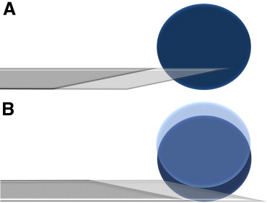
Figure 2. Illustration of “needle safe side” principle. (A) The tip of the needle, the “sharp side,” is pointing toward the object; as the needle is advanced, it is penetrating the object. (B) The bevel side, which is the “safe side,” is facing toward the object; as the needle is advanced, the object is pushed away.
Figure options
According to Badylak and Keene,¹ 4 types of labral penetration occurred: (1) penetration through a labral tear (5 cases); (2) penetration adjacent to a labral tear, making the tear longer (5 cases); (3) partial penetration next to the labrum edge (5 cases); and (4) full penetration of the labrum not continuous with a labral tear (35 cases). All cases with labral tears (47 cases) were treated with excision of the tear. Hence the first 3 options did not significantly change the result of the treatment. As for the fourth group, in which the iatrogenic tear was not near the native labral tear, the new tear was left untreated. Considering evidence that labral debridement has inferior results compared with labral refixation,^{6 and 7} the effect of the iatrogenic labral injury in this group may be masked.
Another limitation of the study that has to be considered is the ceiling effect of the modified Harris Hip Score. Because 60.5% of this score consists of pain tolerance and subjective perception of limp, it is limited in evaluating some patients, especially those who have very high scores preoperatively. This ceiling effect may disguise the detrimental effect of iatrogenic labral penetration.
Overall, the acetabular labrum plays an important role in the hip joint. It has been shown to increase articulating surface by 22% and acetabular volume by 33%.⁸ While in the weight-bearing phase, the labrum seals synovial fluid between the femoral head and acetabulum, driving it into the articular cartilage, providing nutrition and lubrication.⁹ The pressurized synovial fluid also transmits the load within the cartilage layers to the underlying subchondral bone and slows the expression of fluid out of the cartilage matrix, reducing the solid contact stresses on the cartilage.^{10, 11 and 12} Loss of the labral seal has been shown to destabilize the hip in a cadaveric model, increasing femoral head motion with both venting of the capsule and creation of a labral tear.¹³ Clinically, tears of the labrum are believed to lead to accelerated wear of the articular cartilage, as well as early degenerative osteoarthritis.^{14, 15 and 16}
Complications are inevitably under-reported in the surgical literature, and the courage of Badylak and Keene¹ in presenting this complication deserves recognition. However, their conclusion that labral penetration does not affect clinical outcome may be misinterpreted by the reader, who may be led to believe that a high rate of iatrogenic labral injury is acceptable. In our opinion, iatrogenic damage to the labrum does matter and may affect the short- and long-term surgical results.
In summary, there is an overwhelming body of evidence that the labrum serves an important function in the healthy hip joint. For this reason, iatrogenic damage to the labrum must be considered undesirable, and every effort should be made to avoid labral penetration during hip arthroscopy. In light of the observed labral penetration rate of less than 1% in a series of 300 patients, we find the 20% labral penetration rate reported in this study to be quite high. We would therefore offer that the reader may aim to minimize the iatrogenic labral injury in hip arthroscopy and may consider a labral penetration rate of less than 1% to be a realistic goal.

Supplementary data
Video 1. Step-by-step technique for establishment of first portal during hip arthroscopy by use of fluoroscopy.
Help with MPG files
Options

References

  - 1
  - J.S. Badylak, J.S. Keene
  - Do iatrogenic punctures of the labrum affect the clinical results of hip arthroscopy?
  - Arthroscopy, 27 (2011), pp. 761–767
  - [SD-008]

  - 2
  - J.W.T. Byrd, K.S. Jones
  - Prospective analysis of hip arthroscopy with 10-year followup
  - Clin Orthop Relat Res, 468 (2009), pp. 741–746
  - [SD-008]

  - 3
  - J.W. Byrd
  - Avoiding the labrum in hip arthroscopy
  - Arthroscopy, 16 (2000), pp. 770–773
  - [SD-008]

  - 4
  - M.T. Clarke, A. Arora, R.N. Villar
  - Hip arthroscopy: Complications in 1054 cases
  - Clin Orthop Relat Res (2003), pp. 84–88
  - [SD-008]

  - 5
  - Domb BG, Botser IB, Hanypsiak B. Reduction of iatrogenic labral tears during hip arthroscopy using a novel technique for establishment of portals. Presented at the Arthroscopic Association of North America Annual Meeting, San Francisco, California, April 14-16, 2011.
  - [SD-008]

  - 6
  - C.M. Larson, M.R. Giveans
  - Arthroscopic debridement versus refixation of the acetabular labrum associated with femoroacetabular impingement
  - Arthroscopy, 25 (2009), pp. 369–376
  - [SD-008]

  - 7
  - E. Schilders, A. Dimitrakopoulou, Q. Bismil, P. Marchant, C. Cooke
  - Arthroscopic treatment of labral tears in femoroacetabular impingement: A comparative study of refixation and resection with a minimum two-year follow-up
  - J Bone Joint Surg Br, 93 (2011), pp. 1027–1032
  - [SD-008]

  - 8
  - V. Tan, R.M. Seldes, M.A. Katz, A.M. Freedhand, J.J. Klimkiewicz, R.H. Fitzgerald Jr
  - Contribution of acetabular labrum to articulating surface area and femoral head coverage in adult hip joints: An anatomic study in cadavera
  - Am J Orthop, 30 (2001), pp. 809–812
  - [SD-008]

  - 9
  - A.S. Greenwald, J.J. O'Connor
  - The transmission of load through the human hip joint
  - J Biomech, 4 (1971), pp. 507–528
  - [SD-008]

  - 10
  - S.J. Ferguson, J.T. Bryant, R. Ganz, K. Ito
  - The acetabular labrum seal: A poroelastic finite element model
  - Clin Biomech (Bristol, Avon), 15 (2000), pp. 463–468
  - [SD-008]

  - 11
  - S.J. Ferguson, J.T. Bryant, R. Ganz, K. Ito
  - An in vitro investigation of the acetabular labral seal in hip joint mechanics
  - J Biomech, 36 (2003), pp. 171–178
  - [SD-008]

  - 12
  - S.J. Ferguson, J.T. Bryant, K. Ito
  - The material properties of the bovine acetabular labrum
  - J Orthop Res, 19 (2001), pp. 887–896
  - [SD-008]

  - 13
  - M.J. Crawford, C.J. Dy, J.W. Alexander et al.
  - The 2007 Frank Stinchfield AwardThe biomechanics of the hip labrum and the stability of the hip
  - Clin Orthop Relat Res, 465 (2007), pp. 16–22
  - [SD-008]

  - 14
  - A.R. Altenberg
  - Acetabular labrum tears: A cause of hip pain and degenerative arthritis
  - South Med J, 70 (1977), pp. 174–175
  - [SD-008]

  - 15
  - J.C. McCarthy, P.C. Noble, M.R. Schuck, J. Wright, J. Lee
  - The watershed labral lesion: Its relationship to early arthritis of the hip
  - J Arthroplasty, 16 (2001), pp. 81–87
  - [SD-008]

  - 16
  - J.H. Dorrell, A. Catterall
  - The torn acetabular labrum
  - J Bone Joint Surg Br, 68 (1986), pp. 400–403
  - [SD-008]
The authors report that they have no conflicts of interest in the authorship and publication of this letter.

